Declare International Order Form

Product |  | Description | Price | Quantity | Total
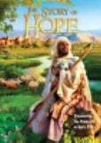 |  | https://www.goodsoil.com/resources/the-story-of-hope-english-version/ | $5.50
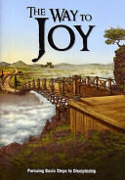 |  | https://www.goodsoil.com/resources/the-way-to-joy-english-version/ | $5.50
Total Cost excluding shipping
Ship to:
Name:
Address:
Suburb:
Postcode:
Email:
Telephone:

Return this form to Declare International by email or post. We will ship the order together with an invoice including actual shipping costs:
Email: austreasurer@abwe.cc
Post: 5C/5-7 Meridian Place, Bella Vista NSW 2153

